User Acceptance Testing (UAT)
Date | 16 June 2026
Name | Mudit Manglik
Project Name | ShopEZ: E-Commerce Application

Project Overview:
Project Name: ShopEZ: E-Commerce Application
Project Description: A responsive full-stack MERN (MongoDB, Express, React, Node) fashion storefront featuring role-based JWT authentication, database-synced carts (with automatic guest-to-member cart merging), shipping checkout forms, order history listings, and a robust administrative panel for managing products, auditing users, and updating delivery statuses.
Project Version: 1.0.0
Testing Period: June 12, 2026 – June 16, 2026
Testing Scope: User registration & login, product catalog query and category filtering, cart operations (adding, updating quantities, deleting, syncing guest local state on login), checkout shipping form validation, order placement transactions, and admin dashboard operations (product CRUD, user listing, order status updates).
Testing Environment:
- URL/Location:
Frontend Client: http://localhost:5173
Backend API Server: http://localhost:5000/api
Credentials (if required):
Customer Account:
- Email: customer@shopez.com
- Password: password123
Administrator Account:
- Email: admin@shopez.com
- Password: adminpassword

Test Cases:
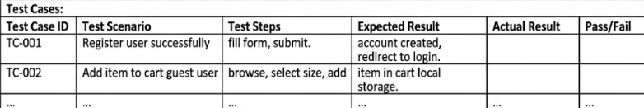
Bug Tracking:
